Table Creation
- Create database & table:
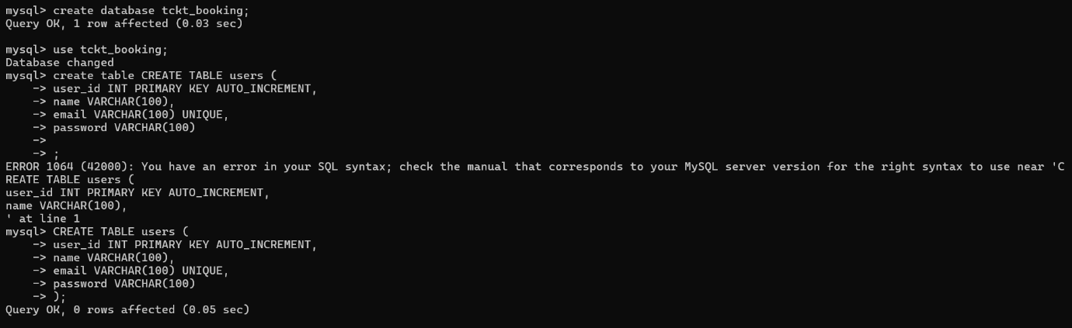
- Insert into users:
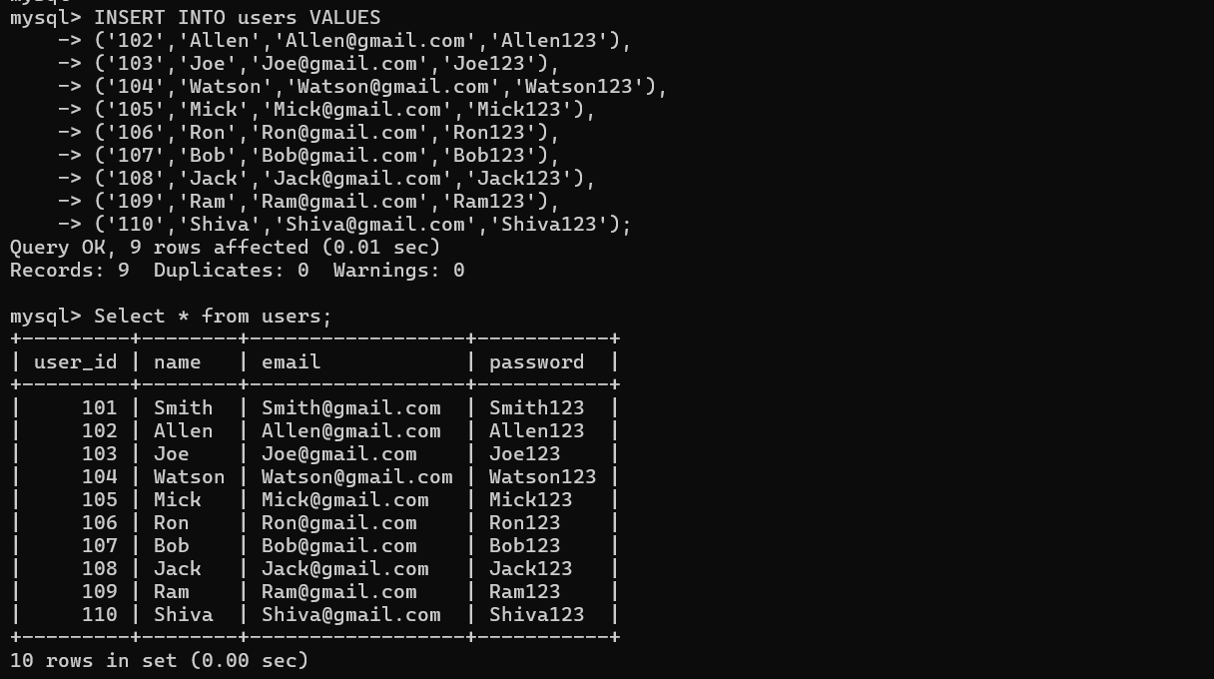

- Create table movies:
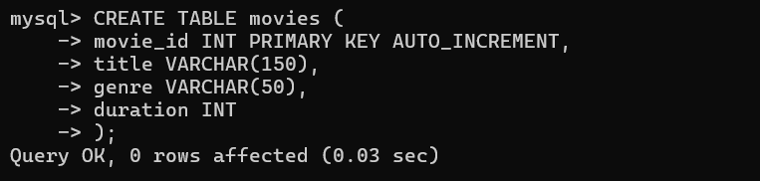

- Insert into movies: 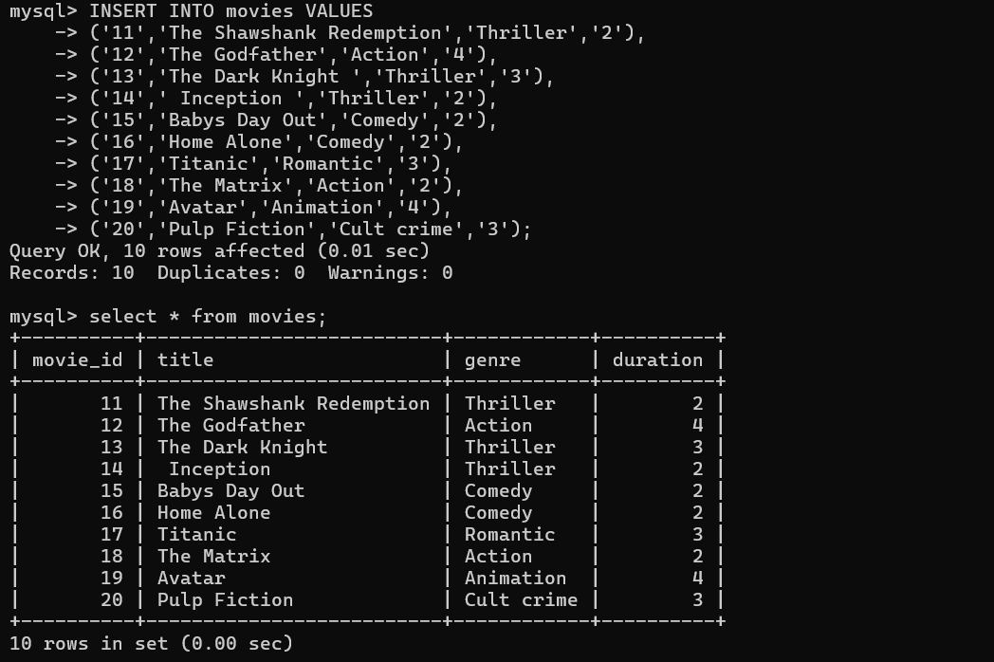
- Create table shows:
- Insert into shows: 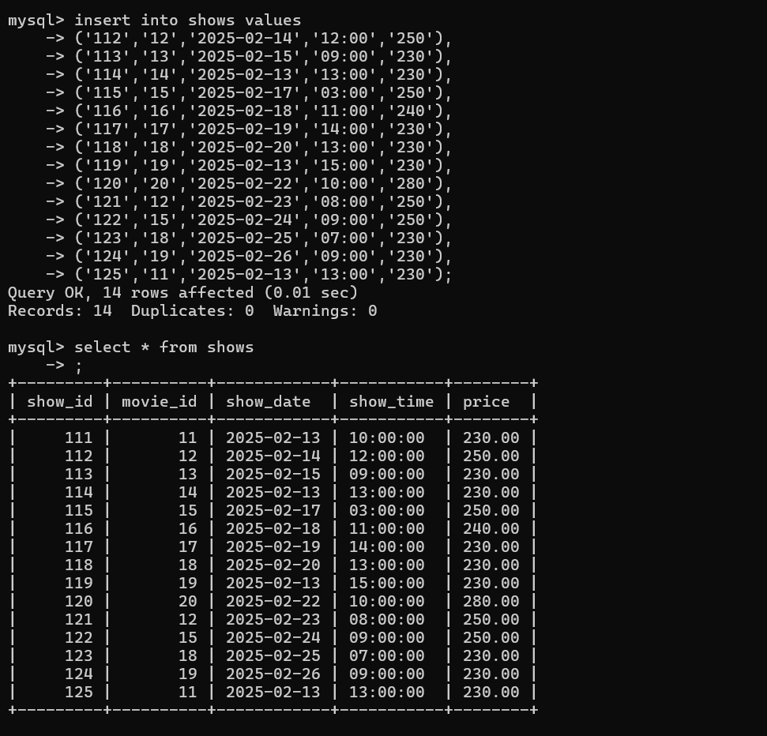
- Create table seats: 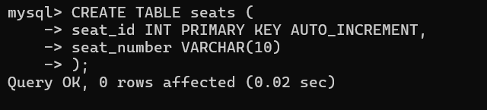

- Insert into seats: 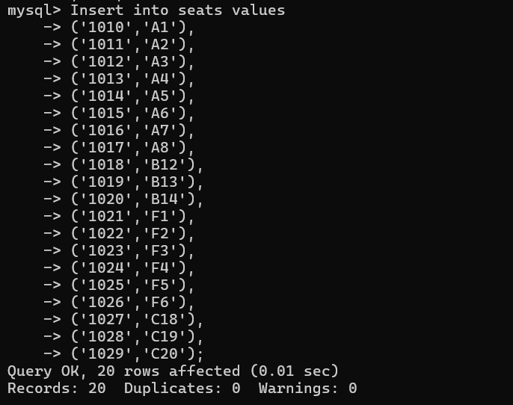

- Seats:
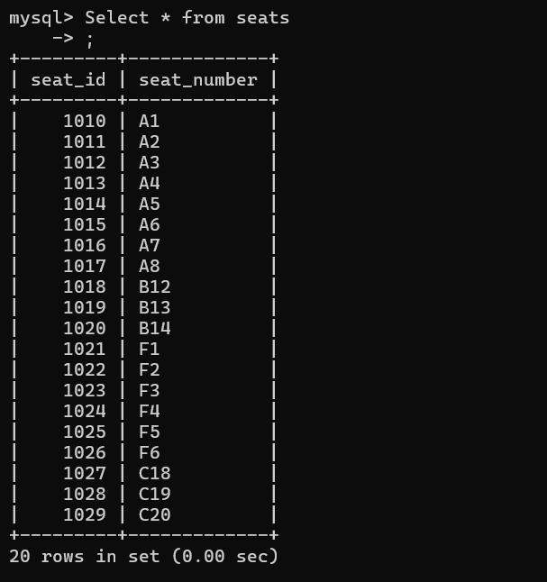

- Create table bookings:
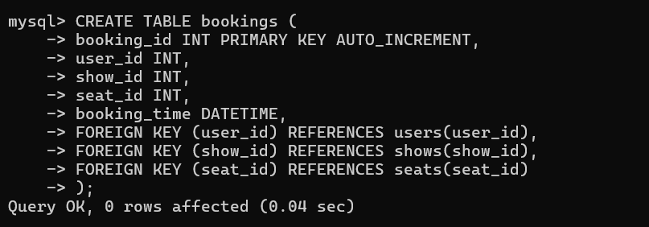

- Insert into bookings: 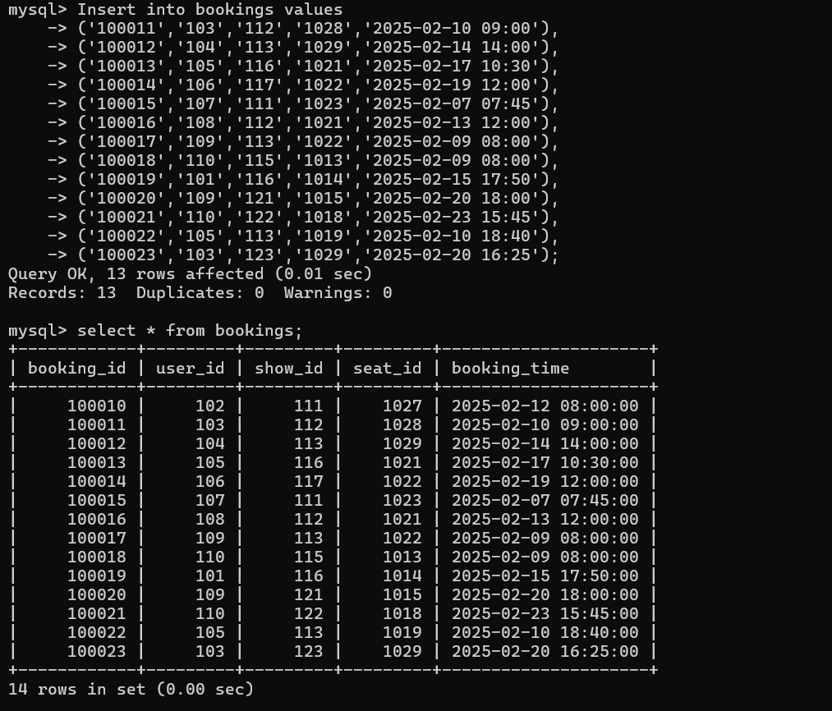

- Movies:
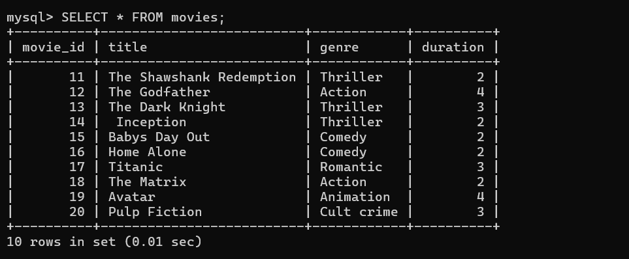
- Shows:
- Seats:
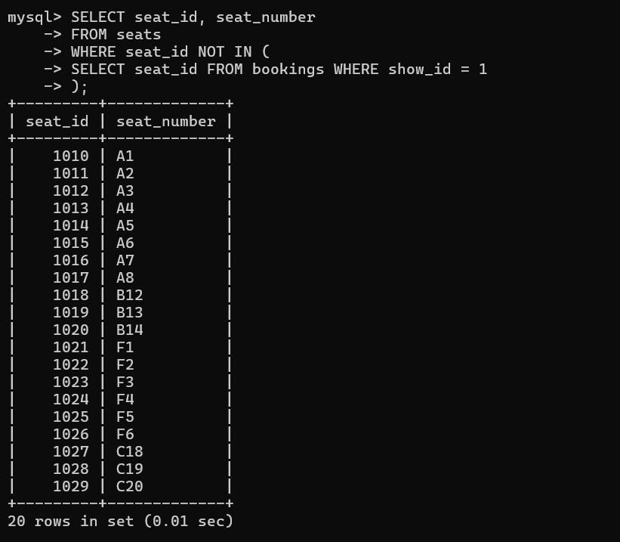

- Insert into bookings:
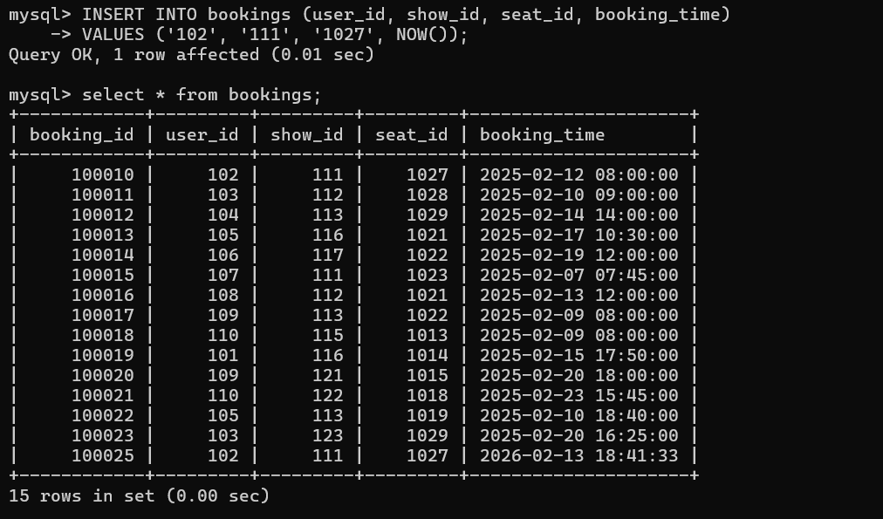

- Bookings: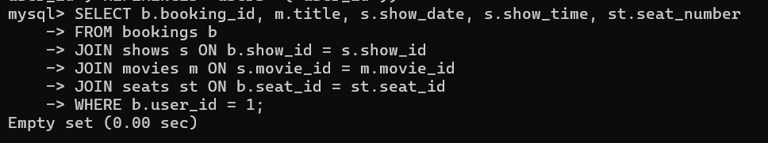

Movie Ticket Booking System
- Write a query to display all users stored in the system.
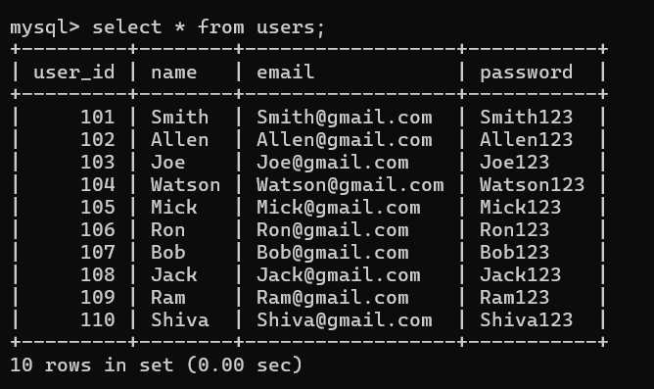

- Write a query to list all movies in the movie table.
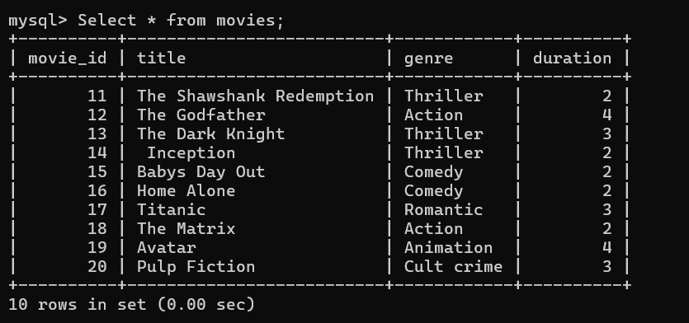

- Write a query to display all available shows.
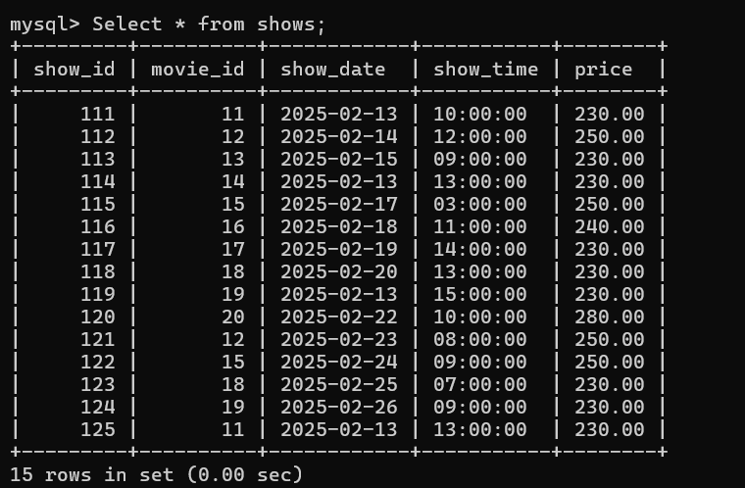

- Write a query to fetch details of a movie using its movie_id.
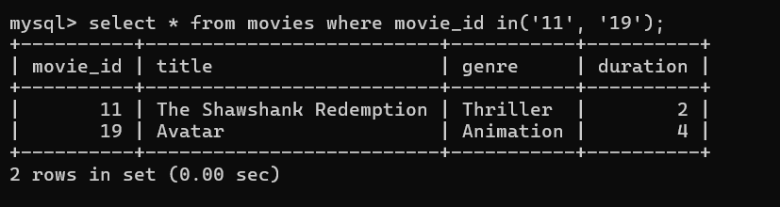

- Write a query to list all shows of a particular movie.
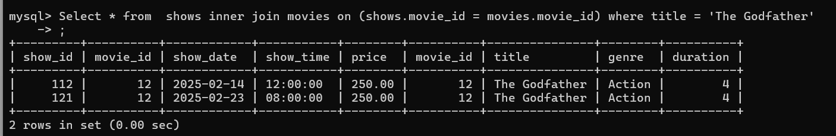

- Write a query to list all seat numbers from the seats table.
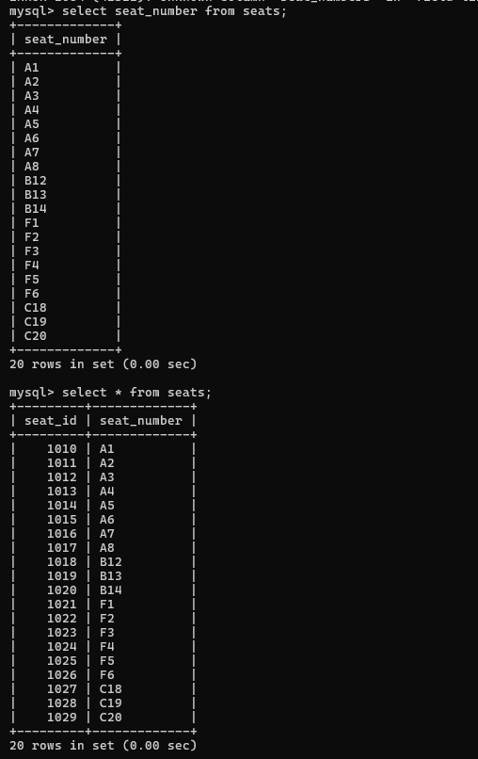

- Write a query to find available seats for a specific show.

- Write a query to display all booked seats for a specific show.
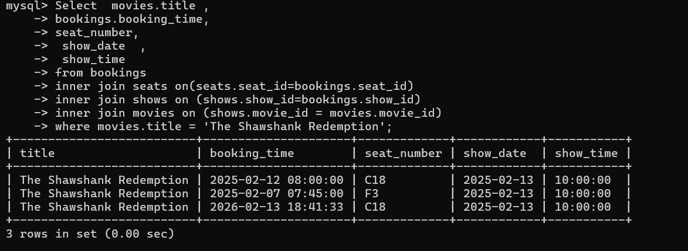

- Write a query to insert a new user into the users table.
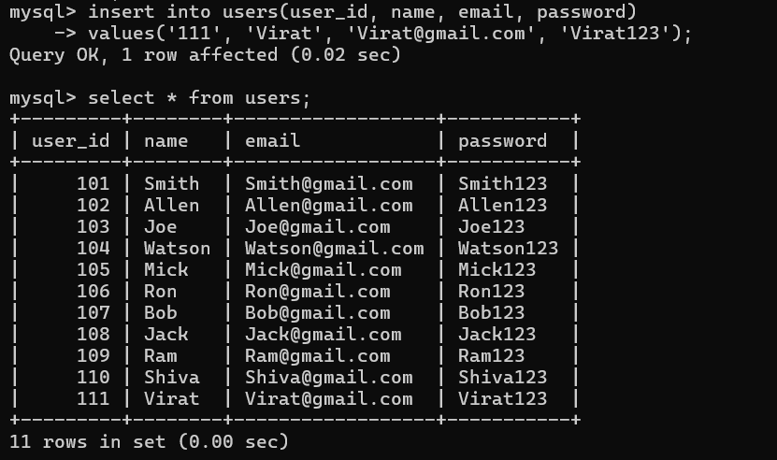

- Write a query to insert a new movie into the movies table.
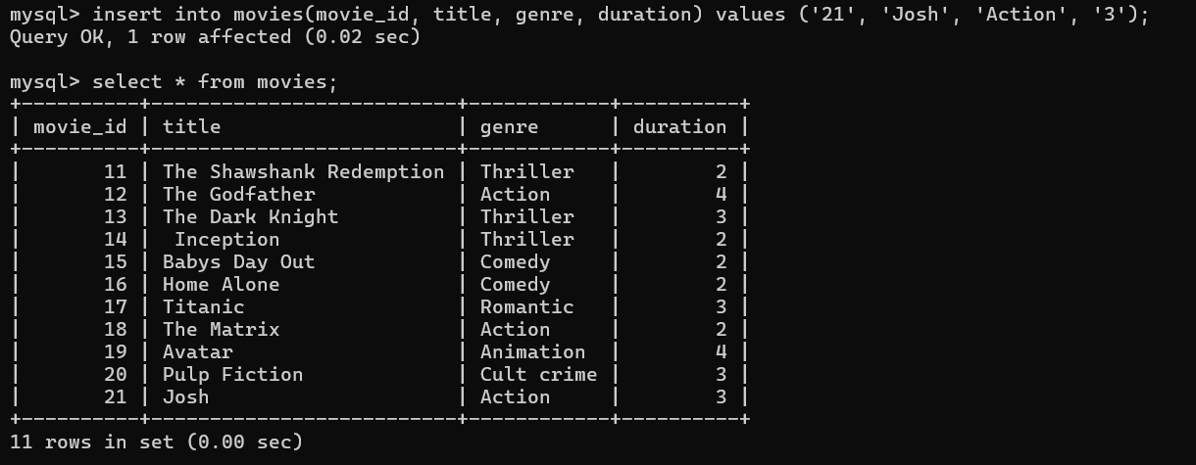
- Write a query to insert a new show into the shows table. 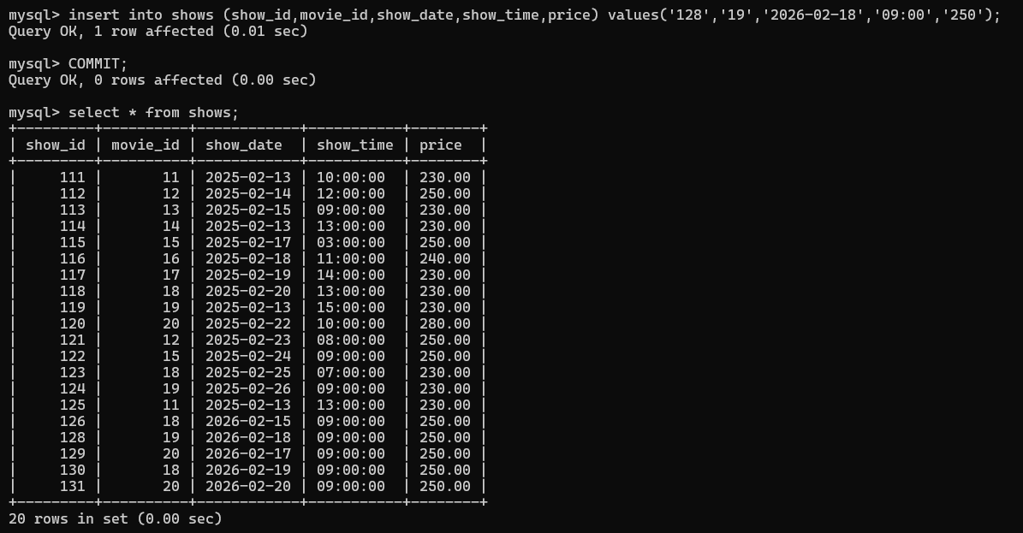

- Write a query to add a new seat to the seats table.
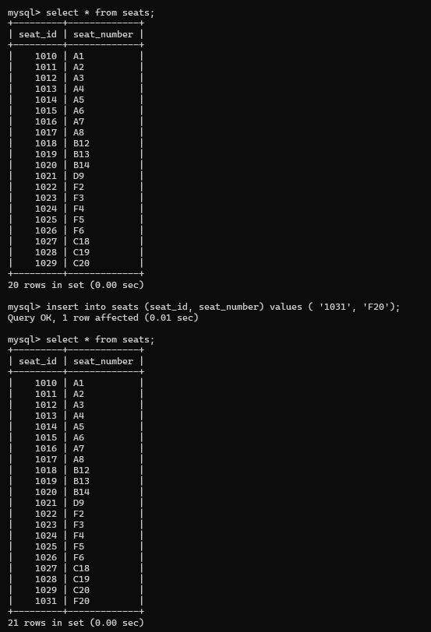
- Write a query to book a ticket for a user.
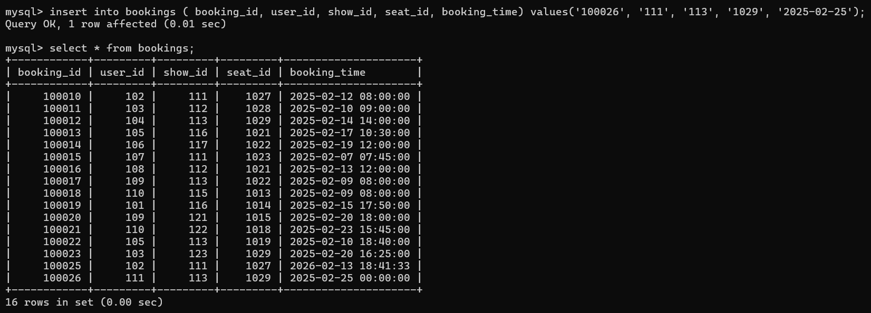

- Write a query to display all bookings.
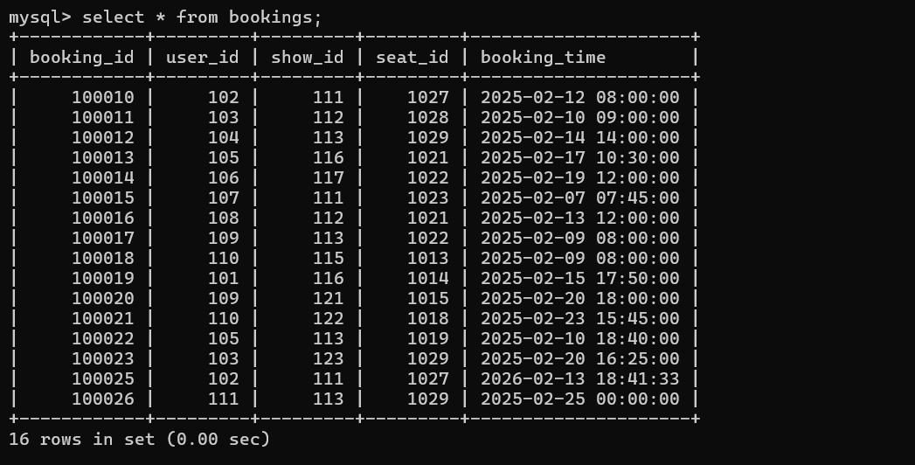

- Write a query to display booking history for a specific user.
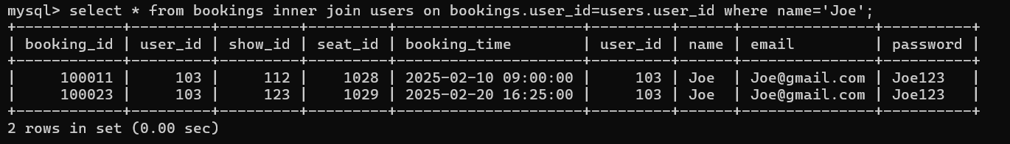

- Write a query to count total bookings for a specific show.
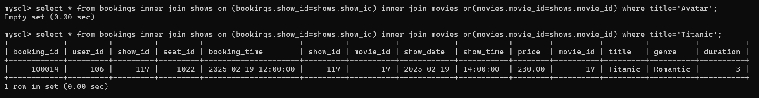

- Write a query to count total bookings for a specific movie.
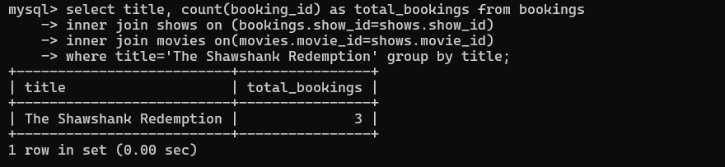

- Write a query to find all movies of a specific genre.
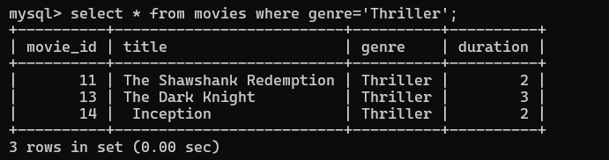

- Write a query to update the duration of a movie.
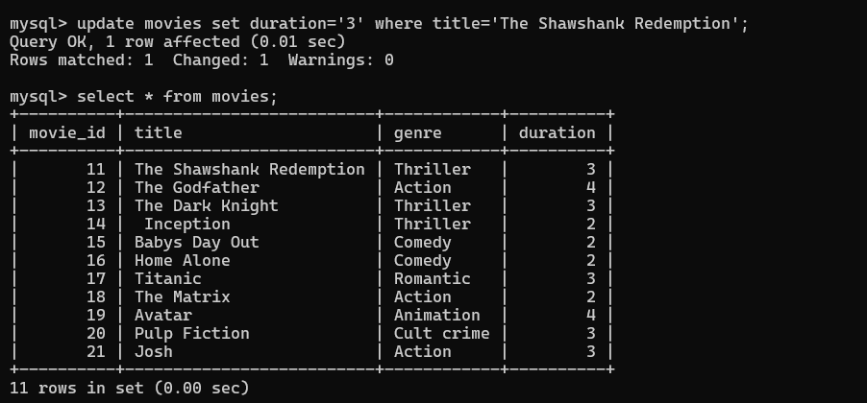

- Write a query to update the seat number for a given seat_id.
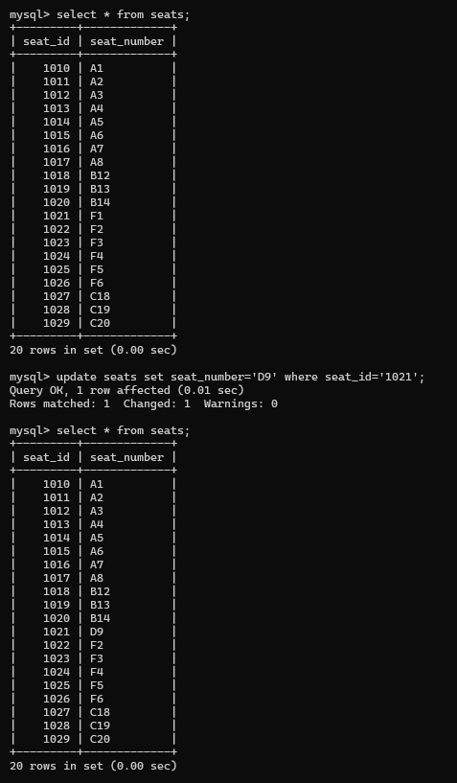

- Write a query to delete a specific booking record.
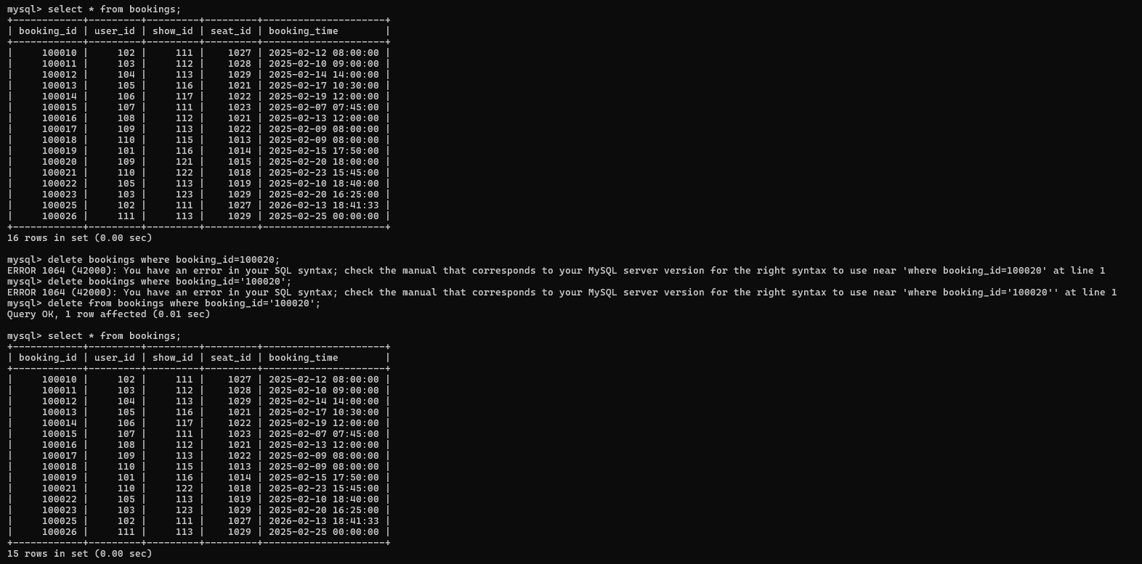
- Write a query to delete a movie from the movies table.
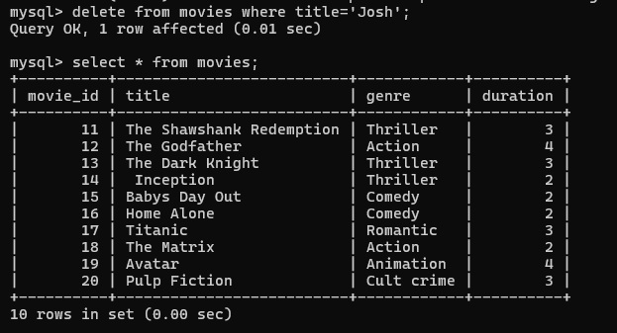

- Write a query to list movies longer than 2 hours.
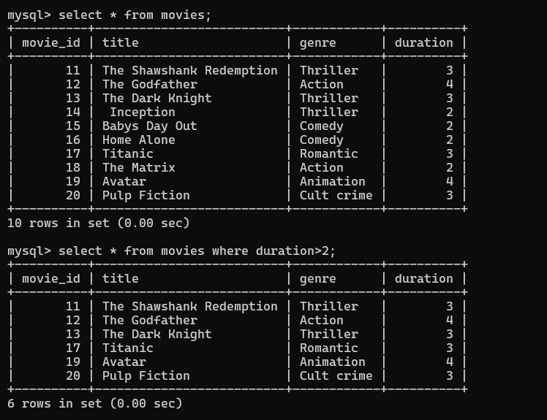

- Write a query to find shows scheduled for today's date.
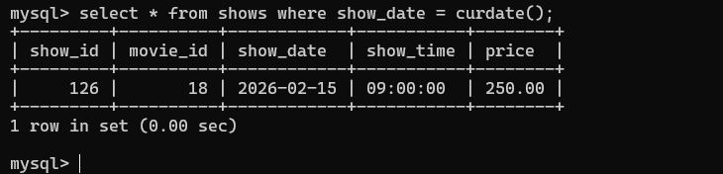

25. Write a query to list upcoming shows sorted by date and time
